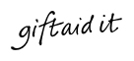

Using Gift Aid means that for every pound you give, we get an extra 25 pence from the Inland Revenue, helping your donation go further.

The Hartford Conservation Group is registered for charitable tax exemption on donations and membership subscriptions. If you are a basic rate taxpayer and would like to help us in this way please sign the declaration.

I want all donations and subscriptions I have made since 6th April 2000 and all donations and subscriptions in the future to be Gift Aid until I notify you otherwise.

Signature………………………….

Date…………………………………

COMMITTEE 2017-18

PRESIDENT Gerald Gibbs
7 The Grove
Hartford

OFFICERS

Chairman Mike Humphrey
14 Main Street
Hartford
gelvum@btconnect.com
01480 436444

Treasurer James Fell
2 The Grove
Hartford
jamesdfell@btinternet.com

Vice Chairman Vacant

Secretary Vacant

COMMITTEE MEMBERS

Betty Trevett Mary Clubb
32 Falcon Drive 8 The Spinney
Hartford Hartford

Angela Owen-Smith
5 Old Houghton Road
Hartford

Juliet Cole Bernie Froggatt
Hartford Cottage 3 Desborough Road
Longstaff Way Hartford
Hartford

MEMBERSHIP SECRETARY

Peter Gibbins 01480 412398
14 Hall Close
Hartford

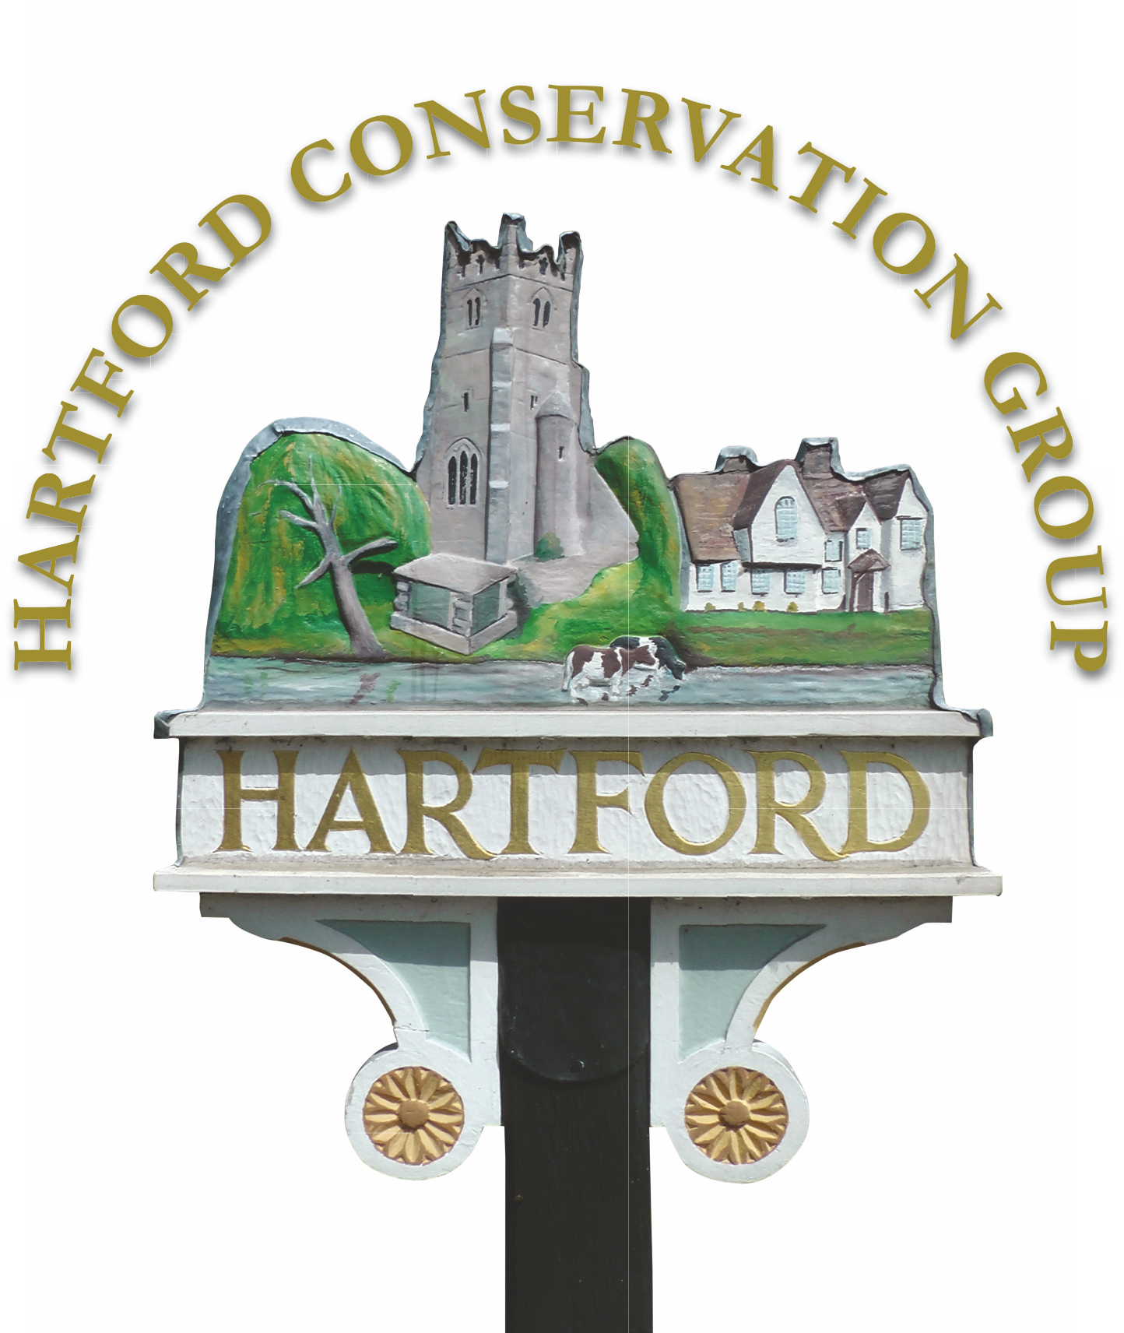

Registered Charity Number

1025575

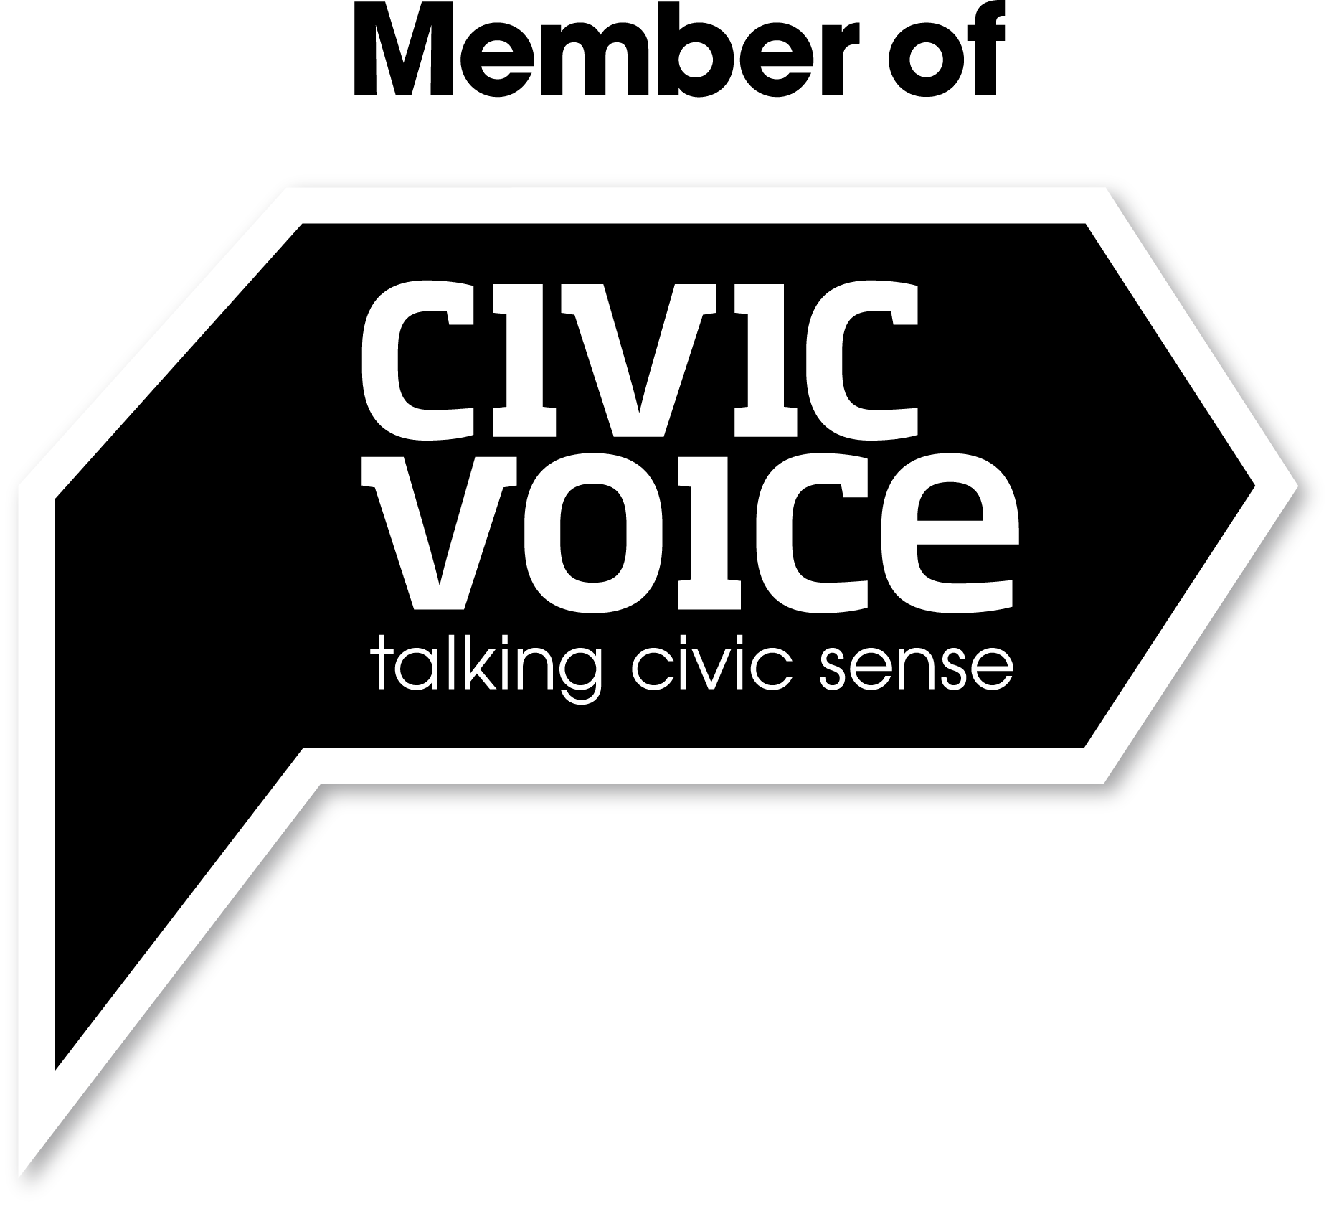
email
hartfordconservationgroup@live.com
info@hartfordconservation.org.uk
website
htpp://www.hartfordconservation.org.uk

